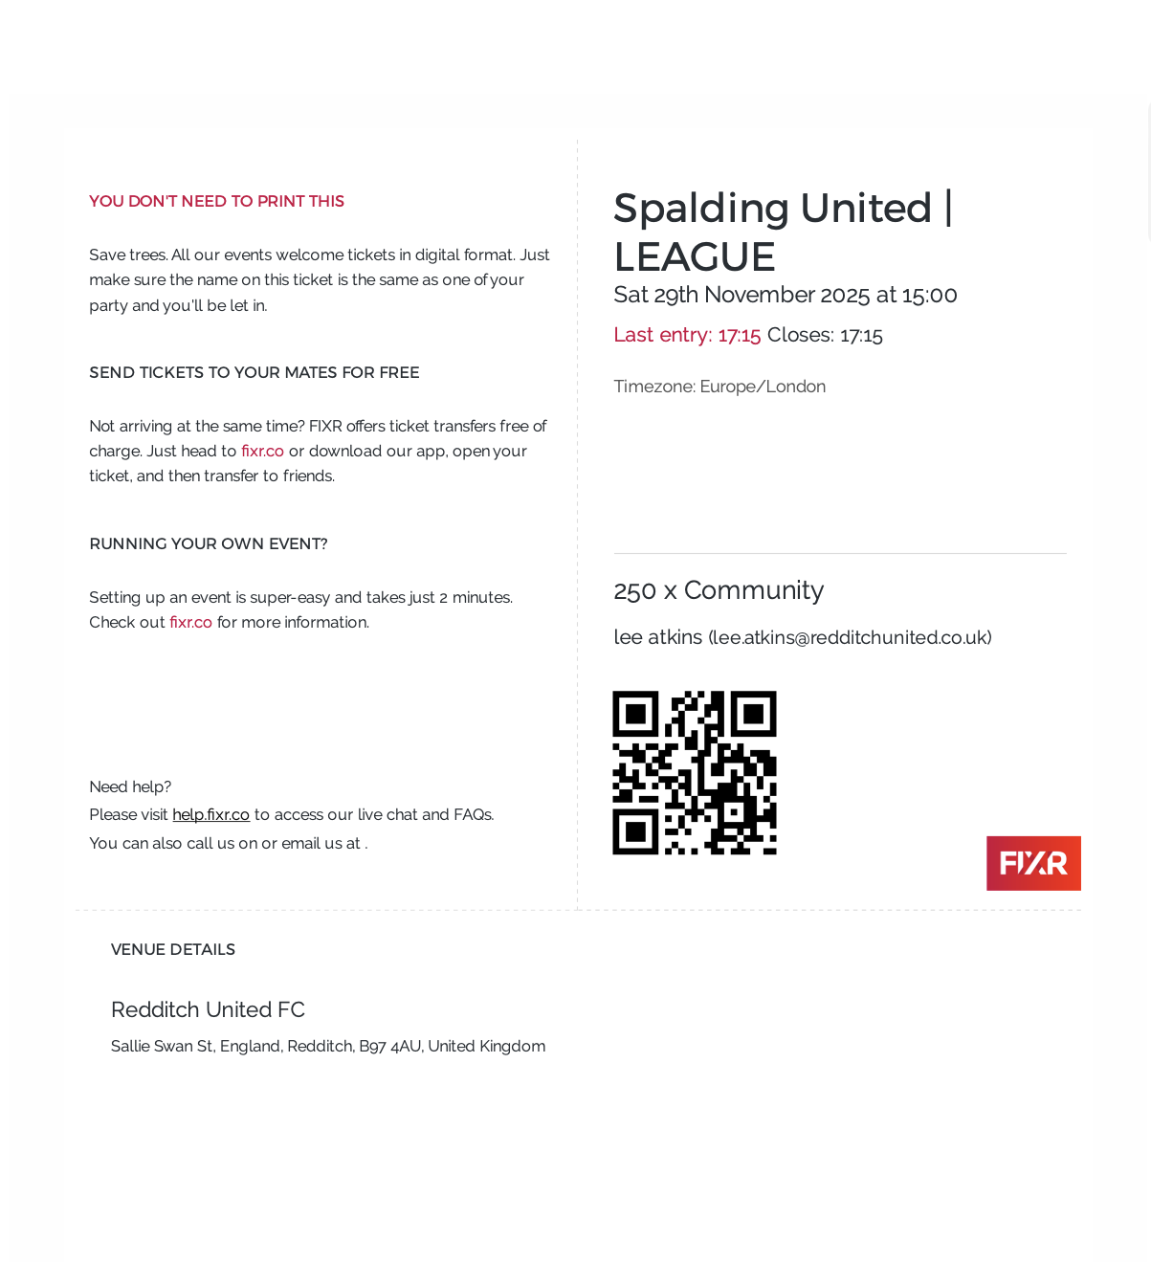
This ticket admits 1 adult per child from Tenacres First School.

