Best Start in Life Newsletter | 
Bromsgrove and Redditch edition
Family Hub News
Family hubs are here to help you and your family access the right support, at the right time.

Our team can support you to connect with local services, community groups, and activities across Redditch and Bromsgrove.
We also offer a range of support including:
- Free or low-cost Healthy start Vitamins
- Breast pump hire
- Volunteering opportunities
- Parenting support and first-time parent groups
- Food parcels
- Advice and guidance around day-to-day concerns such as finances and childcare funding.
- Supporting to access health services, including help finding dentists.

Are you a parent or carer of a 0–5-year-old, or are you expecting a baby?

Practitioners are here for you & your family. Do you need information and support around sleep, behaviour, fussy eating and other common issues parents face? Our practitioners can meet you in the community, at a hub or in the home. Call 01527 61360 (Redditch) or 01527 835775 (Bromsgrove) you can follow this link to complete an online request. www.redditchbc.gov.uk/familyhubrequest
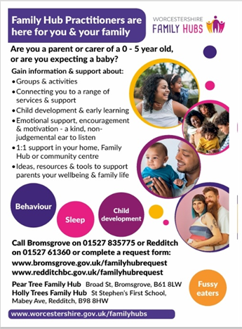

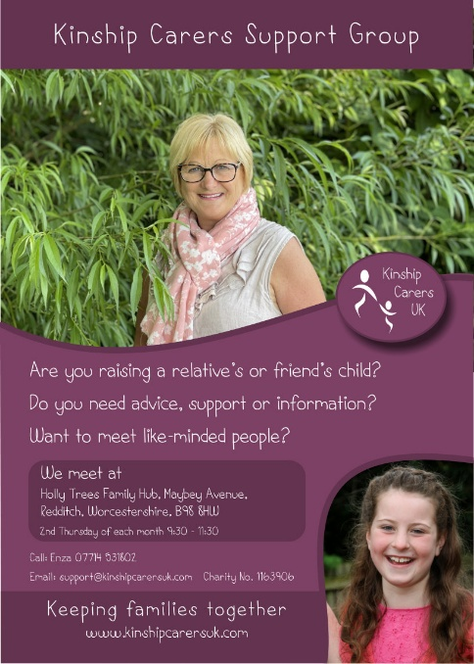
Supporting Kinship Carers
!!!New To Holly trees Family Hub!!!

Are you caring for a child who is not your own, such as grandchild, niece, nephew or family friend? You may be a

kinship carer, and support is available.
We are pleased to welcome Kinship Carers drop-in sessions at Holly trees Family Hub, offering a friendly and informal space to access advice, guidance, and connect with others in a similar situation.


When: Every second Thursday of the month

Time: 9:30 – 11:30
Where: Holly trees Family Hub
No bookings required – just drop in

SENDIAS training at Holly Trees

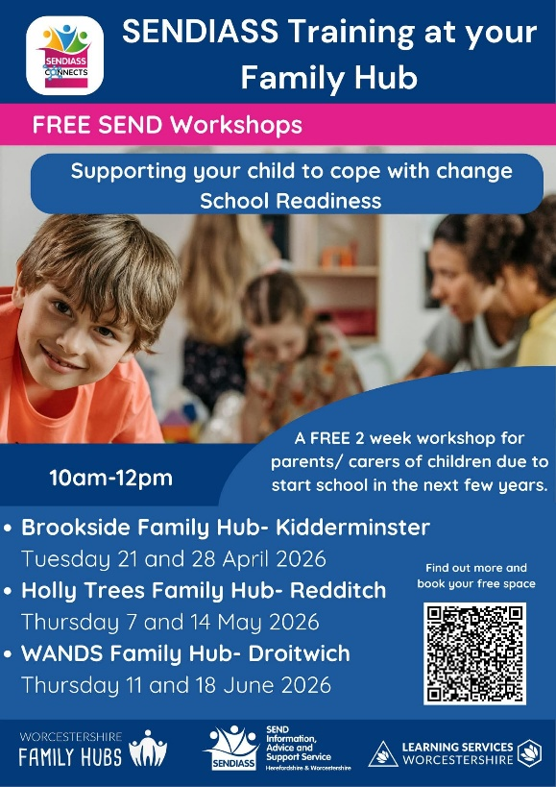

Supporting your child to cope with change and the transition to school is a 2-part workshop aimed at parents/carers of children due to start school in the next few years or are struggling to transition to school.
The first session will focus on supporting children to cope with small everyday changes like moving from one task to another. The second session will focus on the transition to school.
You can expect practical guidance, tips and resources to support your child through change.
𝗥𝗲𝗱𝗱𝗶𝘁𝗰𝗵- Holly Trees Family Hub, 7th and 14th May 10am-12pm
𝗗𝗿𝗼𝗶𝘁𝘄𝗶𝗰𝗵- WANDS Family Hub, 11th and 18th June 10am-12pm

Dental support for Children & Families

Helping you to find the right dental care for you and your family…
If you need routine dental care, you can find a local dentist search by your postcode Find a dentist - NHS
For urgent or emergency dental help, please call 111.
Your Family Hub can also support you—get in touch by calling your local Family Hub
Bromsgrove: 01527 835775
Redditch: 01527 61360

Parenting workshops – Build Confidence, Strengthen Connections

Parenting doesn’t come with a manual – but you don’t have to figure it out alone!

Our workshops are designed to give you practical tools, fresh insights, and the confidence to better understand your child at every stage.

Whether it’s navigating challenging behaviour in the early years or teenage emotions, these friendly and supportive sessions will help you:
- Understand what’s behind your child’s behaviour
- Strengthen relationship and communication
- Learn simple, effective strategies you can use at home
- Connect with other parents going through similar experiences

Parenting workshops – Now booking:

We are currently promoting two of our popular parenting Workshops and would love to welcome more families.
Understanding your Teens brain
- Waseley Hills High School
A Practical and engaging course focused on younger children, helping parents and carers build confidence in understanding behaviour, strengthening relationships, and supporting their child’s development

Understanding your child
- Willow trees community centre
A Practical and engaging course focused on younger children, helping parents and carers build confidence in understanding behaviour, strengthening relationships, and supporting their child’s development

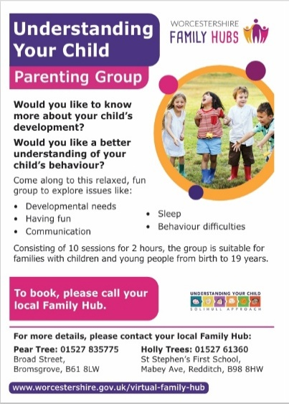
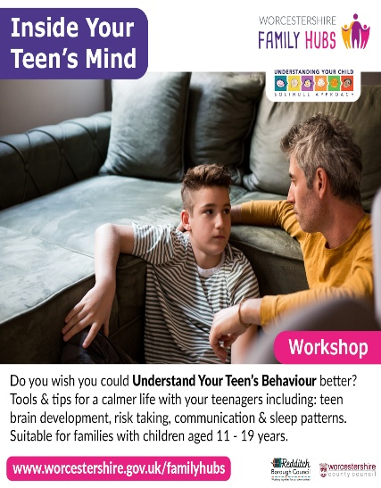

For more information or to book yourself on the workshop please contact family hubs on:
Bromsgrove: 01527 835775
Redditch: 01527 61360
We look forward to seeing you there!!

Physiotherapy Drop-in Clinic


Join us on the first Wednesday of each month at Holly trees Family Hub (1:00 pm – 2:30 pm) Open to children under 5, offering support and guidance around movement and physical development
No bookings required – just Drop in

New Family Hubs pop up Hubs- bring our services to you!

No need to book – pop along and speak to one of the Family Hub team

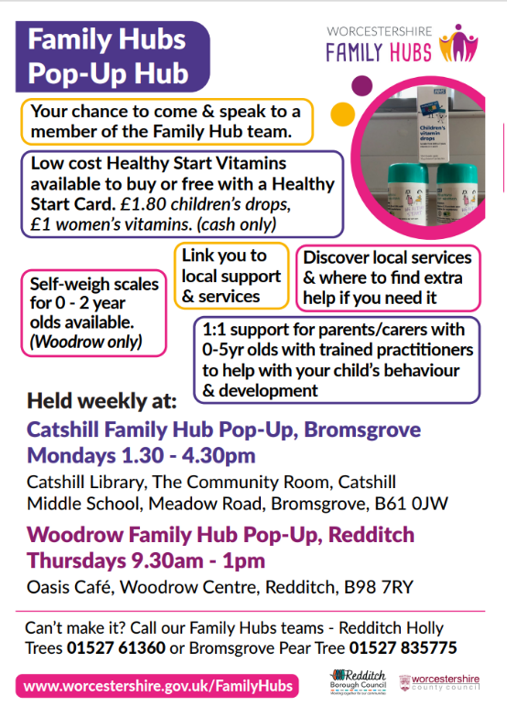
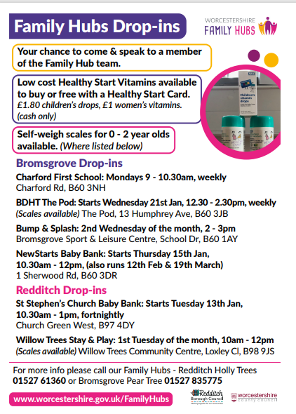

Online resources
Togetherness – emotional health and wellbeing

What is Togetherness?
Togetherness is an online learning platform created by psychologists and health practitioners. It offers easy-to-access courses and resources on emotional health and wellbeing, proven to make a positive difference to mental health, behaviour, and family relationships.

Why is this important for schools and families?
- For parents: Practical strategies to support children’s emotional development, manage behaviour, and strengthen family bonds.
- For schools: Happier, more settled pupils, improved home-school relationships, and resources that complement your PSHE and wellbeing work.

What’s included?
- Courses on understanding your child’s behaviour, emotional health, and parenting through different life stages.
- Support for mental health and resilience for both parents and children.
- All content is NHS-approved, evidence-based, and completely free for local families.

The courses are FREE with access code: PARENTSROCK for residents in our area. There are courses for parents, carers and grandparents about children from bump to 19+ years on a range of topics including pregnancy, teenagers, relationships and more.

Website Worcestershire | Togetherness - Togetherness
Access Code PARENTSROCK

Training for Schools – we offer a 2-day foundation course for professionals that is free to access. For more information, please contact familyhubs@bromsgroveandredditch.gov.uk .

Healthy Start


With Healthy Start, you could be entitled to weekly support towards: Veg, Fruit, Milk, Infant formula milk, Pulses and Healthy Start Vitamins.
Vitamins are available from our Family Hubs.
Find out if you are eligible and apply: www.healthystart.nhs.uk
Booking System


Some of our parenting groups and workshops can now be booked directly by parents/carers using the trybooking system. Scan the QR code or visit www.worcestershire.gov.uk/groups
Stop Smoking
Smoke Free Homes
Looking to stop smoking? We can help! If you have children aged 0-19 in your home you can get free advice to start your quitting journey. 80% of cigarette smoke is invisible and the best thing you can do to protect you and your family from the harms of second-hand smoke is to quit smoking. This support is available to you through your local Family Hub. Scan the QR Code to sign up or if you need help signing up? Any Worcestershire Library can help. To find out more visit: www.worcestershire.gov.uk/stopsmoking Or you can sign up by emailing: whcnhs.smokefreehomes@nhs.net



Useful Links & Community Information
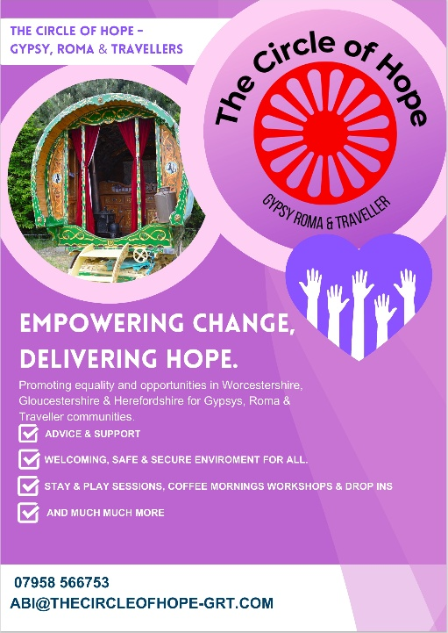
The circle of hope – Gypsy Roma & Traveller

The Circle of Hope – Gypsy Roma & Traveller is an organisation dedicated to promoting equality and creating opportunities for Gypsy, Roma, and Traveller communities across Worcestershire, Gloucestershire, and Herefordshire. We provide cultural awareness training to help professionals and local organisations understand and engage with these communities more effectively. Our team also offers direct support for community members, helping to address social, educational, and cultural needs. By building bridges between the Gypsy, Roma, and Traveller communities and wider society, we work to challenge stereotypes and encourage inclusion

Family Fun and Support Worcestershire is a large directory of activities, events and sessions for families with children aged 0-16 years as well as support and classes for expectant parents.

https://familyfunandsupport.com/
Facebook - familyfunandsupportworcestershire

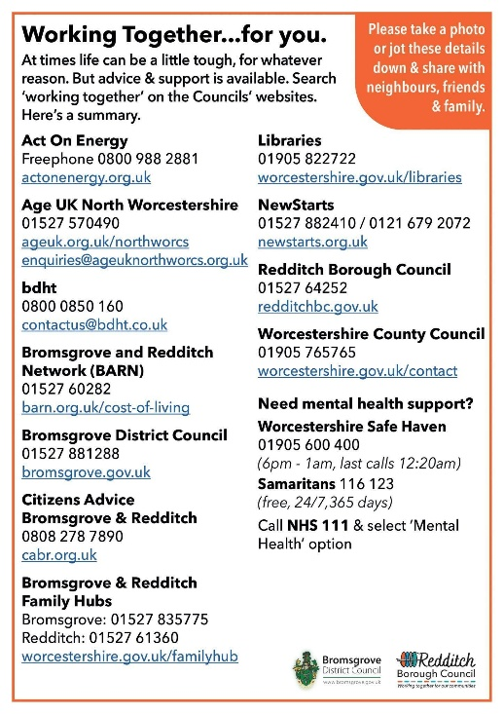

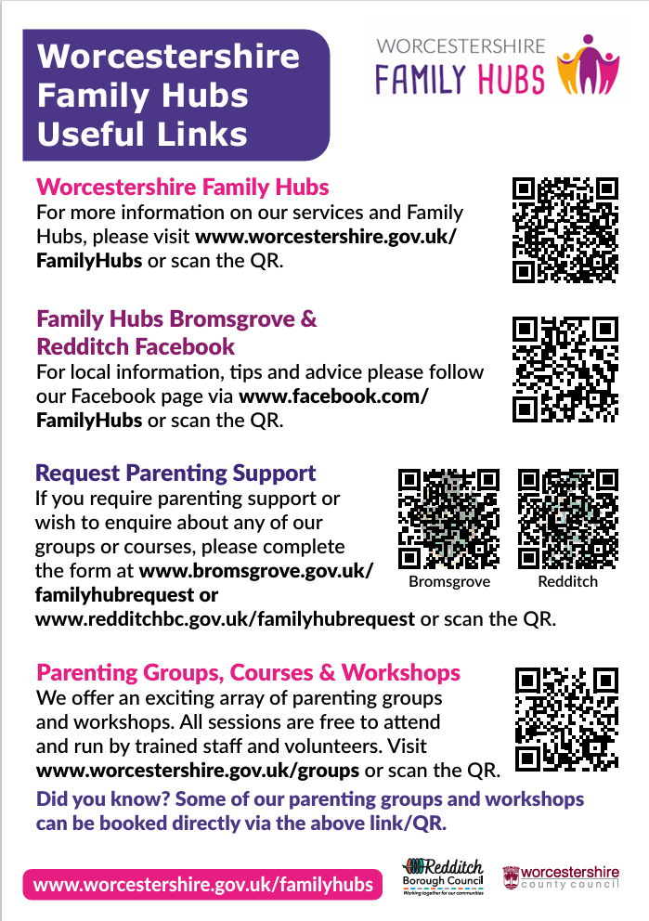

Keep In Touch
Family Hubs - Bromsgrove and Redditch | Facebook
- Holly Trees Family Hub, Mabey Ave, Redditch, B98 8HW
Phone: 01527 61360
- Pear Tree Family Hub, Broad Street, Bromsgrove, B61 8LW

Phone: 01527 835775

